For More Visit www.current-affairs.org

RBI Assistant Solved question Paper 2012
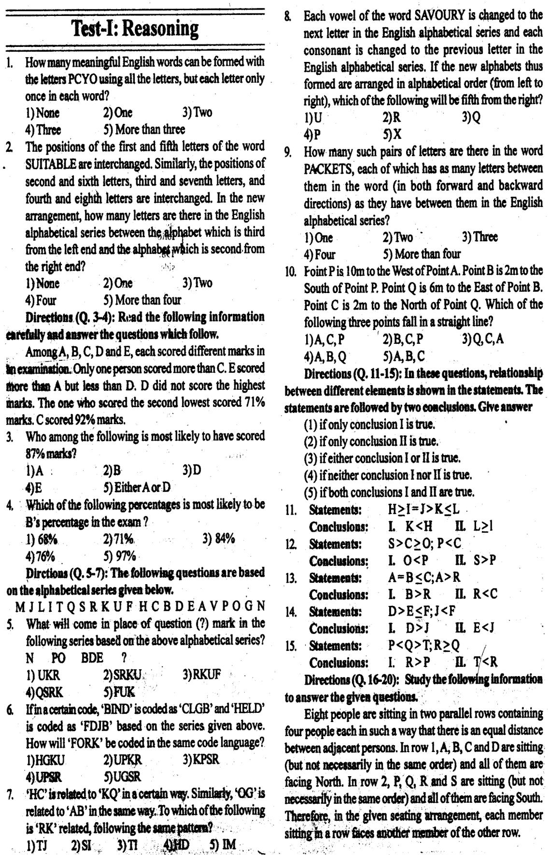

RBI Assistant Solved question Paper 2012

For More Visit www.current-affairs.org

RBI Assistant Solved question Paper 2012
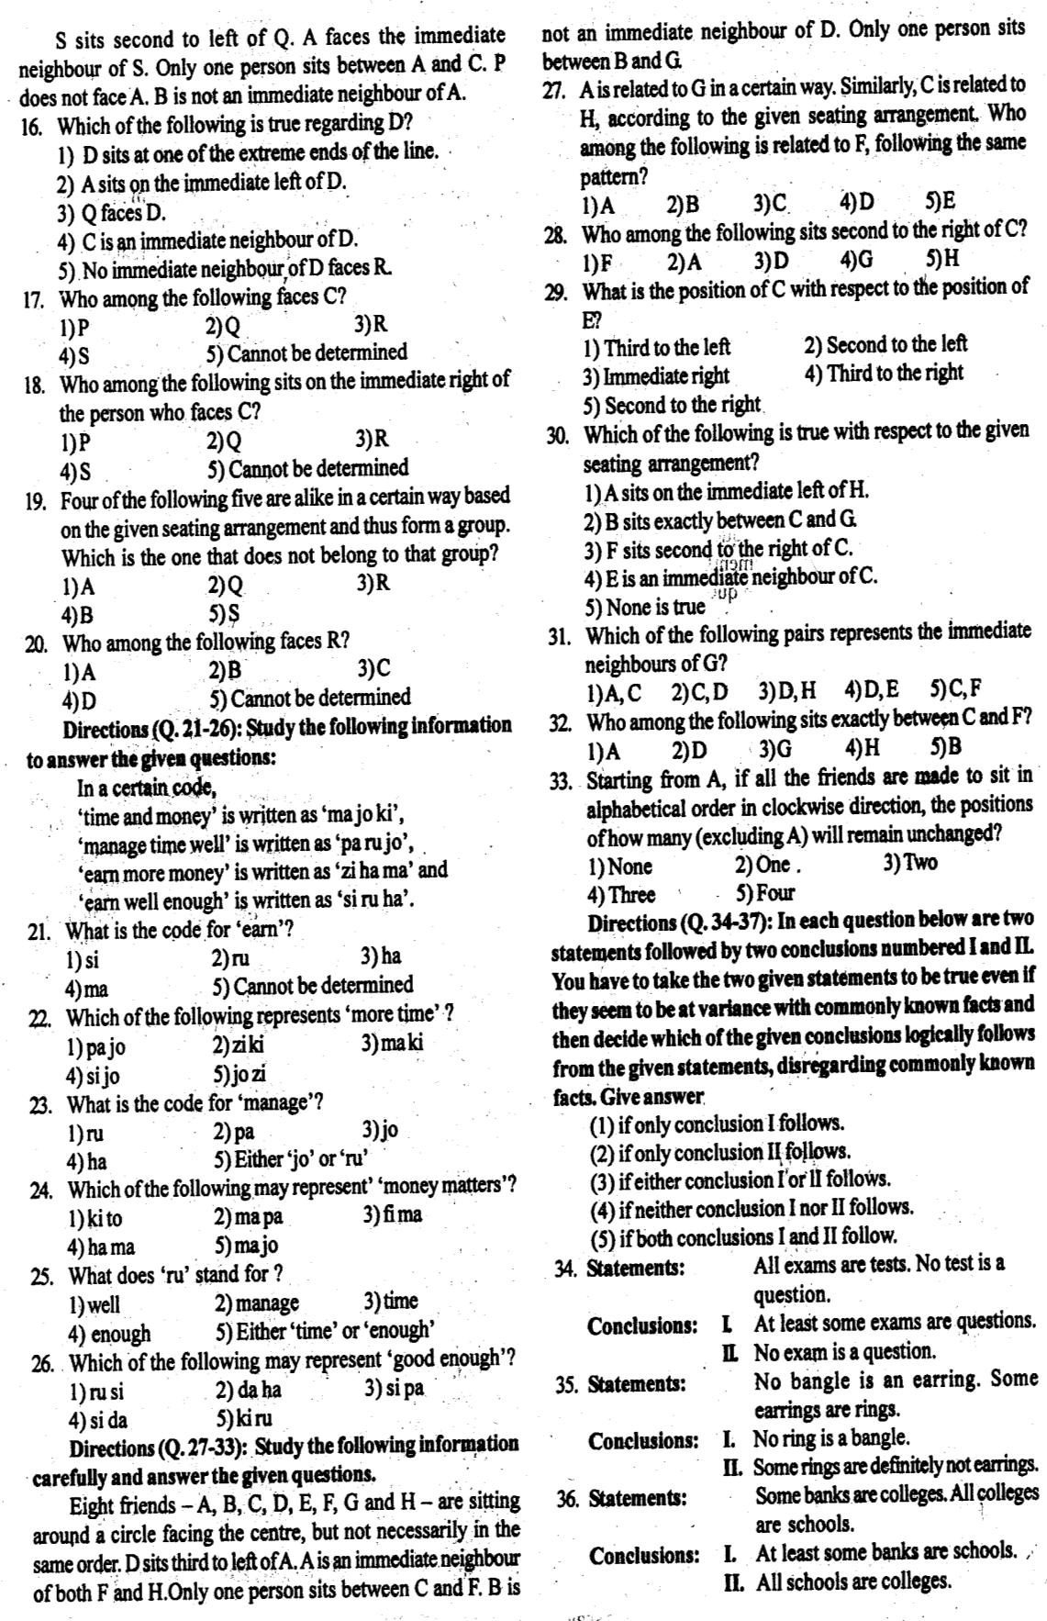

For More Visit www.current-affairs.org

RBI Assistant Solved question Paper 2012

For More Visit www.current-affairs.org

RBI Assistant Solved question Paper 2012
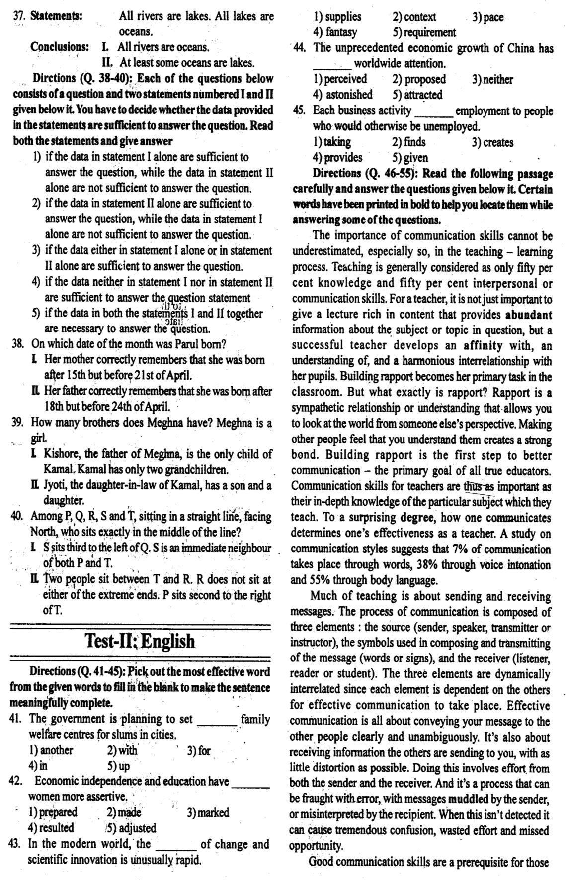

For More Visit www.current-affairs.org

RBI Assistant Solved question Paper 2012

For More Visit www.current-affairs.org

RBI Assistant Solved question Paper 2012

For More Visit www.current-affairs.org

RBI Assistant Solved question Paper 2012

For More Visit www.current-affairs.org

RBI Assistant Solved question Paper 2012
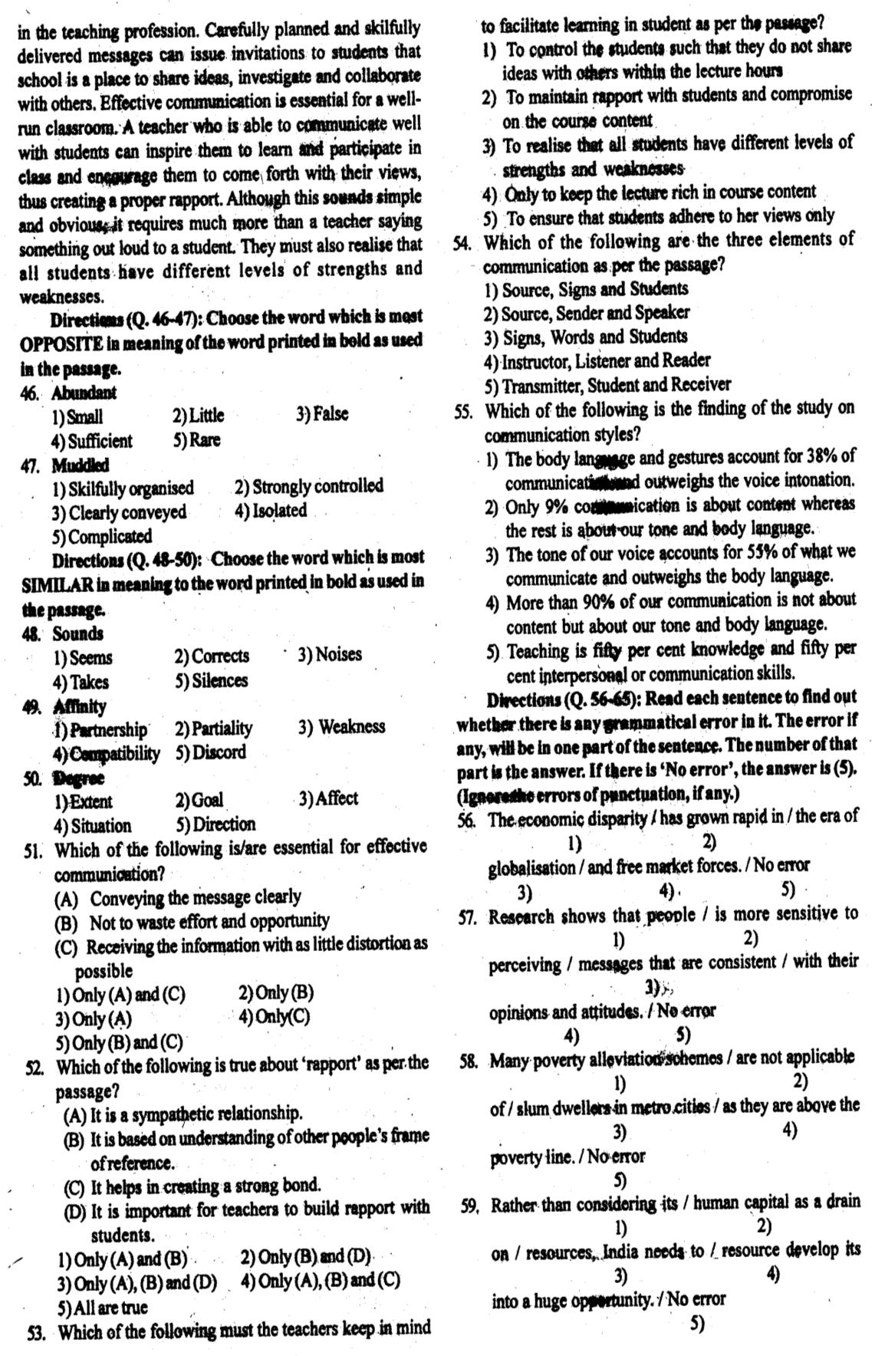

For More Visit www.current-affairs.org

RBI Assistant Solved question Paper 2012

For More Visit www.current-affairs.org

RBI Assistant Solved question Paper 2012

For More Visit www.current-affairs.org

RBI Assistant Solved question Paper 2012

For More Visit www.current-affairs.org

RBI Assistant Solved question Paper 2012
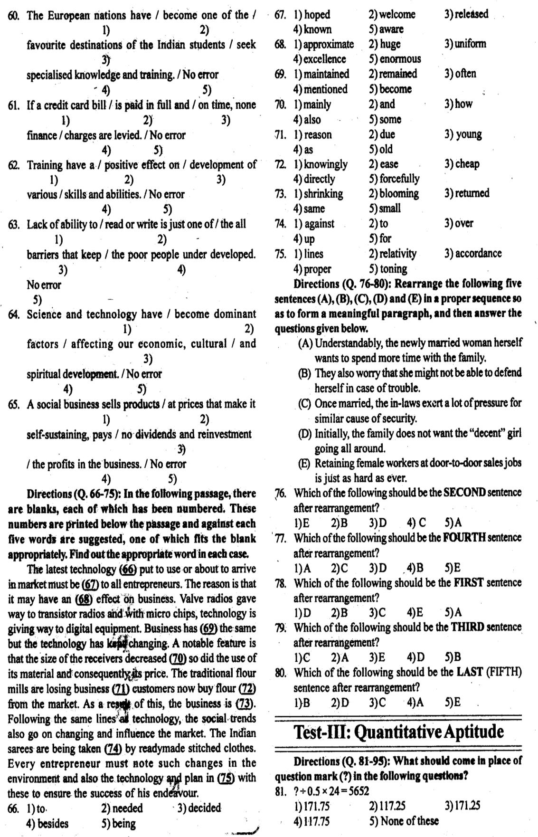

For More Visit www.current-affairs.org

RBI Assistant Solved question Paper 2012

For More Visit www.current-affairs.org

RBI Assistant Solved question Paper 2012

For More Visit www.current-affairs.org

RBI Assistant Solved question Paper 2012

For More Visit www.current-affairs.org

RBI Assistant Solved question Paper 2012
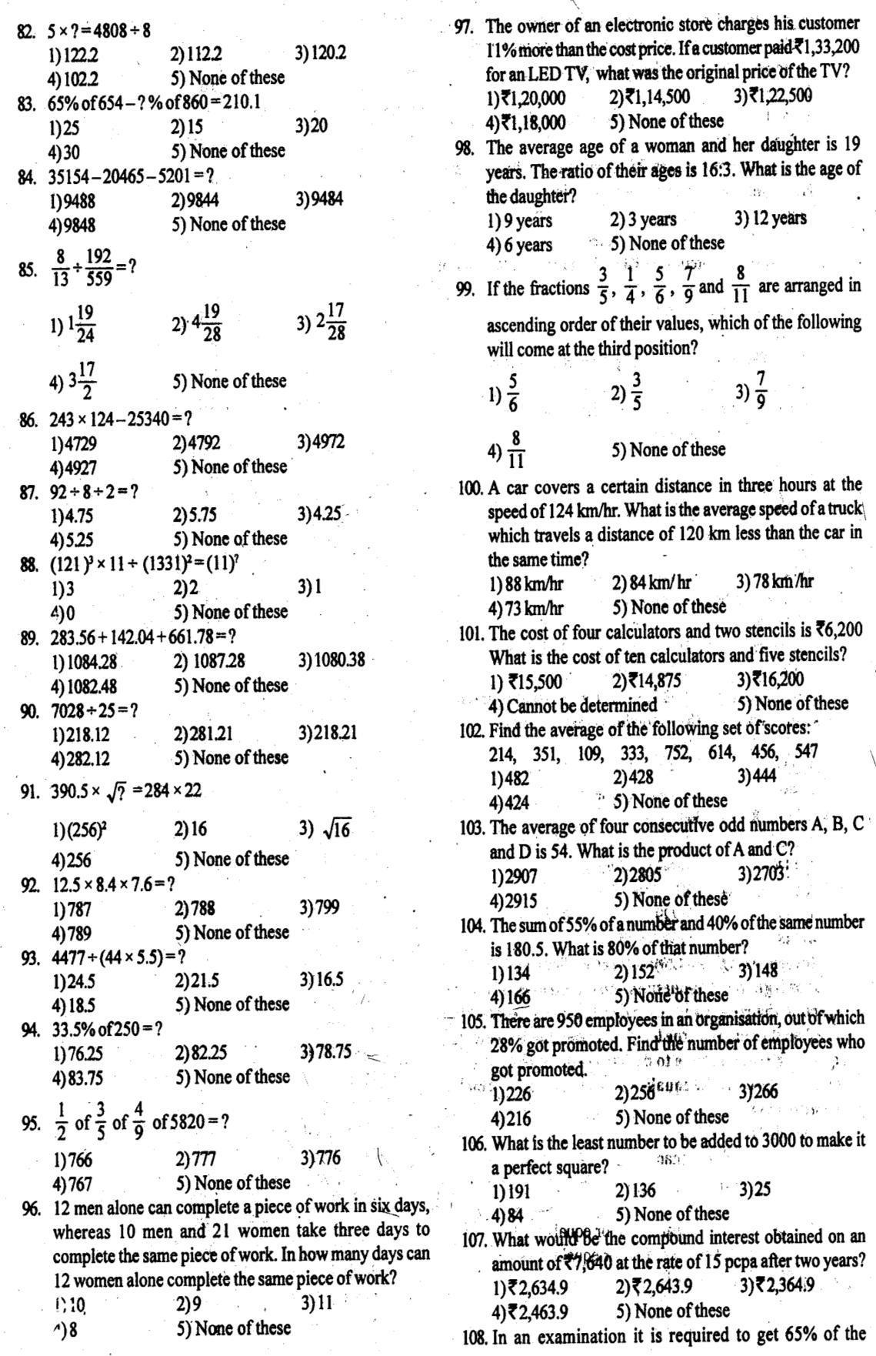

For More Visit www.current-affairs.org

RBI Assistant Solved question Paper 2012

For More Visit www.current-affairs.org

RBI Assistant Solved question Paper 2012
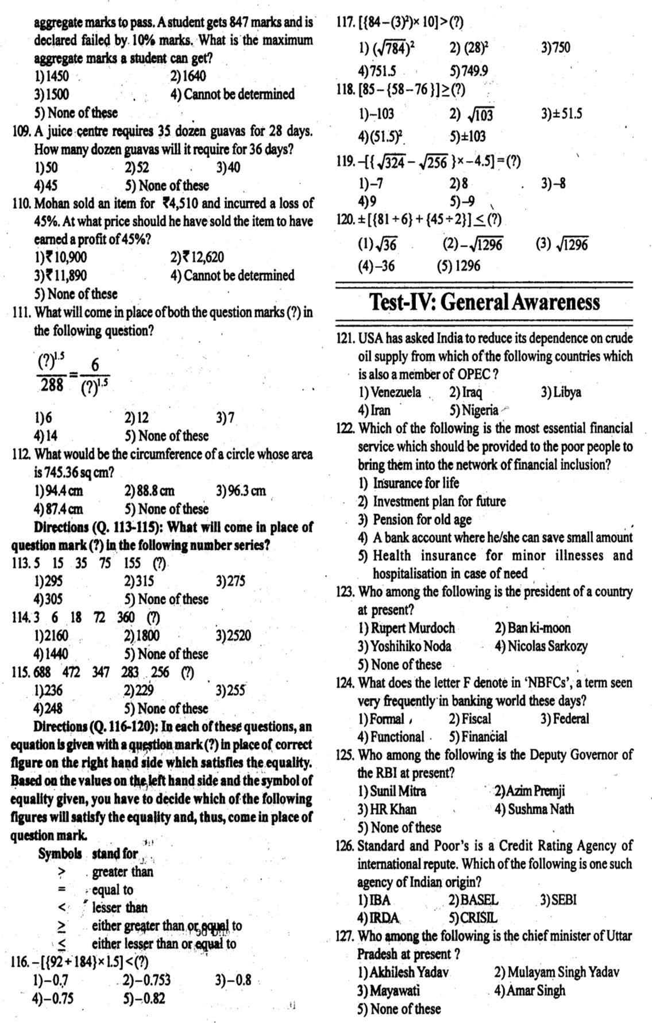

For More Visit www.current-affairs.org

RBI Assistant Solved question Paper 2012

For More Visit www.current-affairs.org

RBI Assistant Solved question Paper 2012
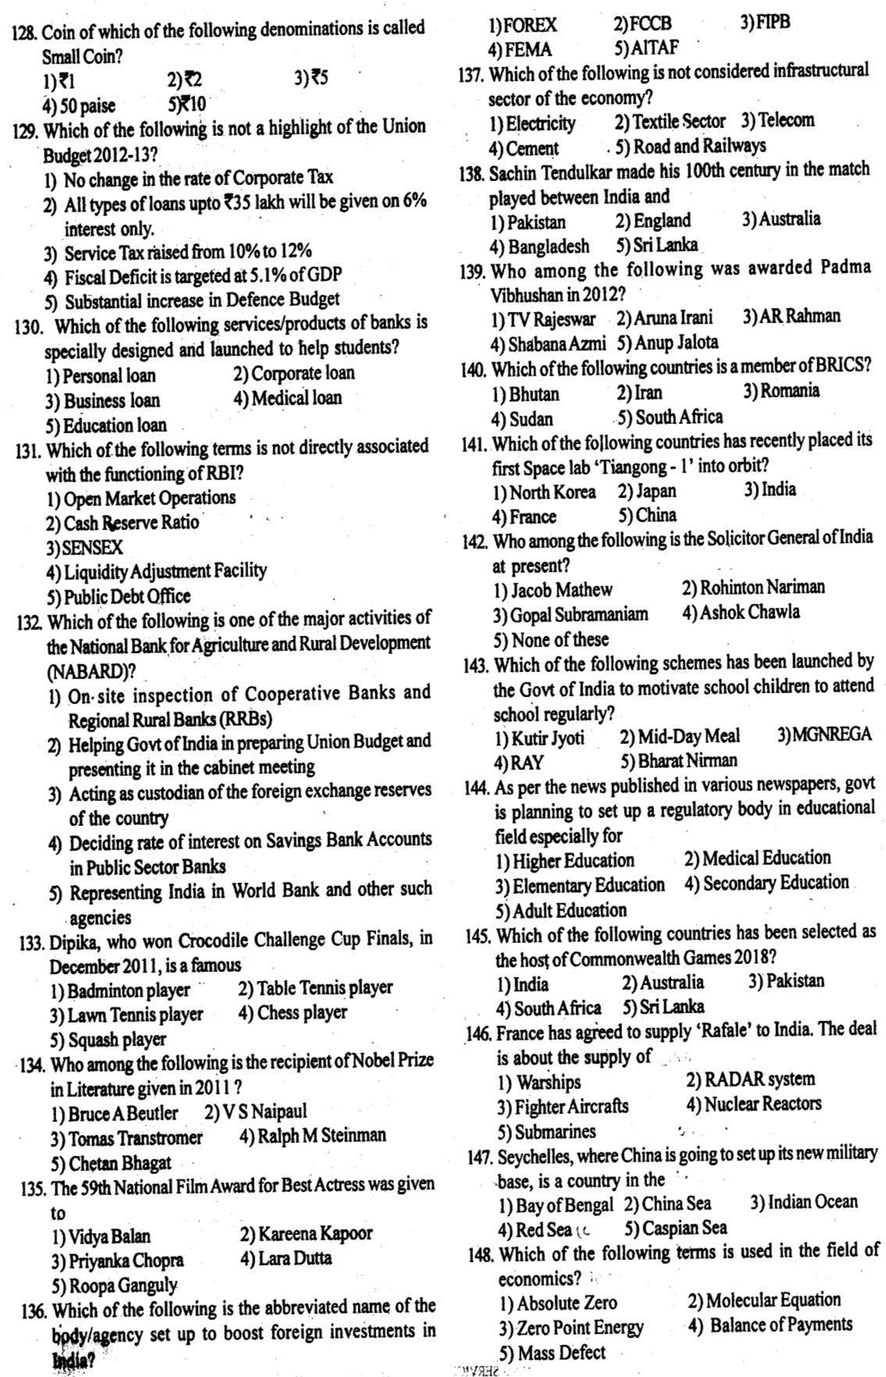

For More Visit www.current-affairs.org

RBI Assistant Solved question Paper 2012

For More Visit www.current-affairs.org

RBI Assistant Solved question Paper 2012
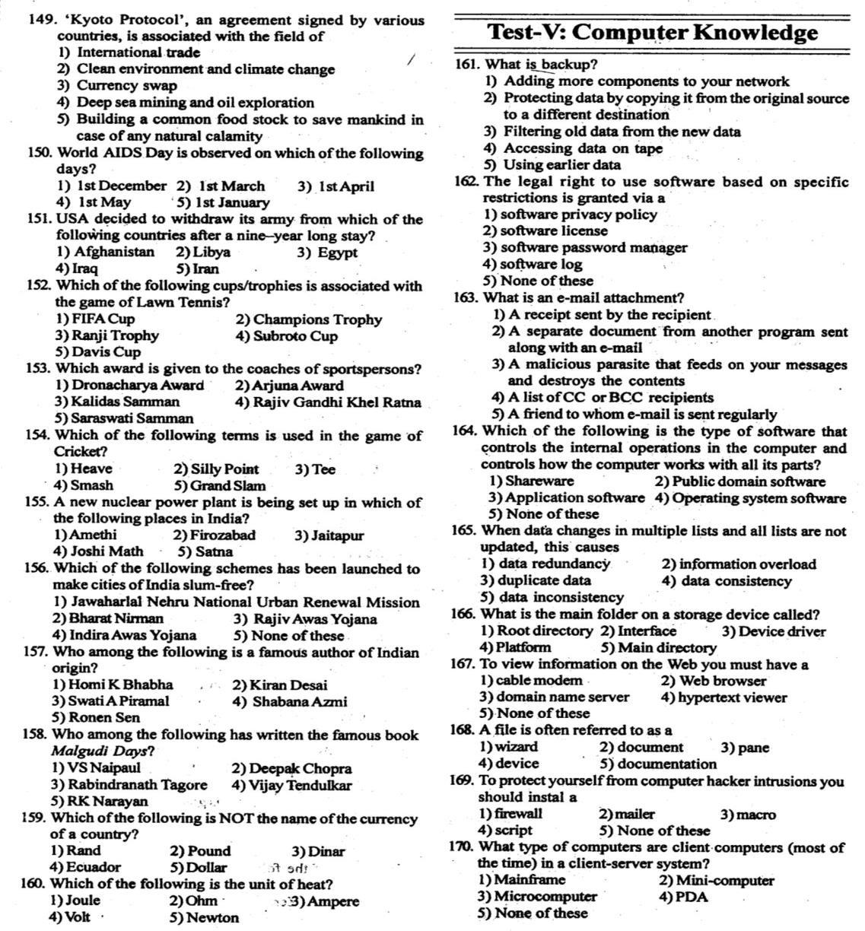

For More Visit www.current-affairs.org

RBI Assistant Solved question Paper 2012

For More Visit www.current-affairs.org

RBI Assistant Solved question Paper 2012

For More Visit www.current-affairs.org

RBI Assistant Solved question Paper 2012

For More Visit www.current-affairs.org

RBI Assistant Solved question Paper 2012
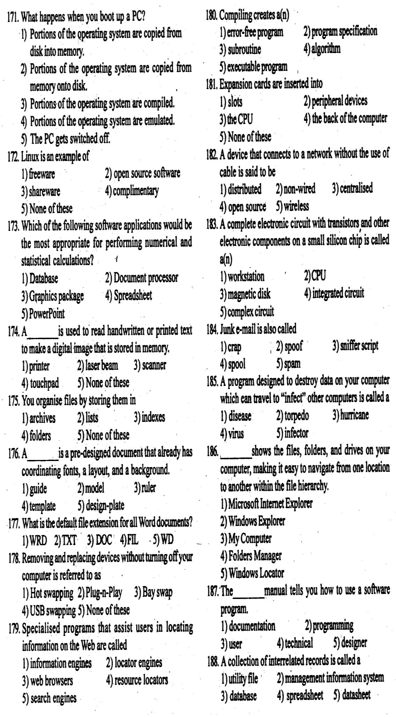

For More Visit www.current-affairs.org

RBI Assistant Solved question Paper 2012

For More Visit www.current-affairs.org

RBI Assistant Solved question Paper 2012

1 | (2) |  | 41 |  | (5) |  | 81 |  | (4) | 121 |  | (4) |  | 161 |  | (2)
2 | (3) |  | 42 |  | (2) |  | 82 |  | (3) | 122 |  | (4) |  | 162 |  | (2)
3 | (3) |  | 43 |  | (3) |  | 83 |  | (1) | 123 |  | (4) |  | 163 |  | (2)
4 | (5) |  | 44 |  | (5) |  | 84 |  | (1) | 124 |  | (5) |  | 164 |  | (4)
5 | (2) |  | 45 |  | (4) |  | 85 |  | (1) | 125 |  | (3) |  | 165 |  | (5)
6 | (4) |  | 46 |  | (2) |  | 86 |  | (2) | 126 |  | (5) |  | 166 |  | (1)
7 | (1) |  | 47 |  | (3) |  | 87 |  | (2) | 127 |  | (1) |  | 167 |  | (2)
8 | (3) |  | 48 |  | (1) |  | 88 |  | (3) | 128 |  | (4) |  | 168 |  | (2)
9 | (2) |  | 49 |  | (4) |  | 89 |  | (5) | 129 |  | (2) |  | 169 |  | (1)
10 | (1) |  | 50 |  | (1) |  | 90 |  | (5) | 130 |  | (5) |  | 170 |  | (1)
11 | (1) |  | 51 |  | (1) |  | 91 |  | (4) | 131 |  | (3) |  | 171 |  | (1)
12 | (2) |  | 52 |  | (5) |  | 92 |  | (5) | 132 |  | (1) |  | 172 |  | (2)
13 | (5) |  | 53 |  | (3) |  | 93 |  | (4) | 133 |  | (5) |  | 173 |  | (4)
14 | (4) |  | 54 |  | (1) |  | 94 |  | (4) | 134 |  | (3) |  | 174 |  | (3)
15 | (5) |  | 55 |  | (4) |  | 95 |  | (3) | 135 |  | (1) |  | 175 |  | (4)
16 | (4) |  | 56 |  | (2) |  | 96 |  | (2) | 136 |  | (3) |  | 176 |  | (4)
17 | (1) |  | 57 |  | (2) |  | 97 |  | (1) | 137 |  | (2) |  | 177 |  | (3)
18 | (2) |  | 58 |  | (2) |  | 98 |  | (4) | 138 |  | (4) |  | 178 |  | (2)
19 | (5) |  | 59 |  | (4) |  | 99 |  | (4) | 139 |  | (1) |  | 179 |  | (5)
20 | (1) |  | 60 |  | (4) |  | 100 |  | (2) | 140 |  | (5) |  | 180 |  | (5)
21 | (3) |  | 61 |  | (3) |  | 101 |  | (1) | 141 |  | (5) |  | 181 |  | (1)
22 | (5) |  | 62 |  | (5) |  | 102 |  | (5) | 142 |  | (2) |  | 182 |  | (5)
23 | (2) |  | 63 |  | (3) |  | 103 |  | (2) | 143 |  | (2) |  | 183 |  | (4)
24 | (3) |  | 64 |  | (5) |  | 104 |  | (2) | 144 |  | (1) |  | 184 |  | (5)
25 | (1) |  | 65 |  | (3) |  | 105 |  | (3) | 145 |  | (2) |  | 185 |  | (4)
26 | (4) |  | 66 |  | (5) |  | 106 |  | (3) | 146 |  | (2) |  | 186 |  | (2)
27 | (4) |  | 67 |  | (4) |  | 107 |  | (4) | 147 |  | (3) |  | 187 |  | (3)
28 | (3) |  | 68 |  | (5) |  | 108 |  | (5) | 148 |  | (4) |  | 188 |  | (3)
29 |  | (1) |  | 69 |  | (2) |  | 109 |  |  | (4) |  | 149 |  | (2)
30 |  | (5) |  | 70 |  | (2) |  | 110 |  |  | (3) |  | 150 |  | (1)
31 |  | (2) |  | 71 |  | (4) |  | 111 |  |  | (2) |  | 151 |  | (4)
32 |  | (5) |  | 72 |  | (4) |  | 112 |  |  | (5) |  | 152 |  | (5)
33 |  | (2) |  | 73 |  | (1) |  | 113 |  |  | (2) |  | 153 |  | (1)
34 |  | (2) |  | 74 |  | (3) |  | 114 |  |  | (1) |  | 154 |  | (2)
35 |  | (4) |  | 75 |  | (3) |  | 115 |  |  | (4) |  | 155 |  | (3)
36 |  | (1) |  | 76 |  | (3) |  | 116 |  |  | (1) |  | 156 |  | (3)
37 |  | (5) |  | 77 |  | (2) |  | 117 |  |  | (5) |  | 157 |  | (2)
38 |  | (4) |  | 78 |  | (4) |  | 118 |  |  | (5) |  | 158 |  | (5)
39 |  | (5) |  | 79 |  | (5) |  | 119 |  |  | (4) |  | 159 |  | (4)
40 |  | (2) |  | 80 |  | (4) |  | 120 |  |  | (3) |  | 160 |  | (1

For More Visit www.current-affairs.org

RBI Assistant Solved question Paper 2012

For More Visit www.current-affairs.org

RBI Assistant Solved question Paper 2012

For More Visit www.current-affairs.org

RBI Assistant Solved question Paper 2012

